BONANZATOUR COMPANY
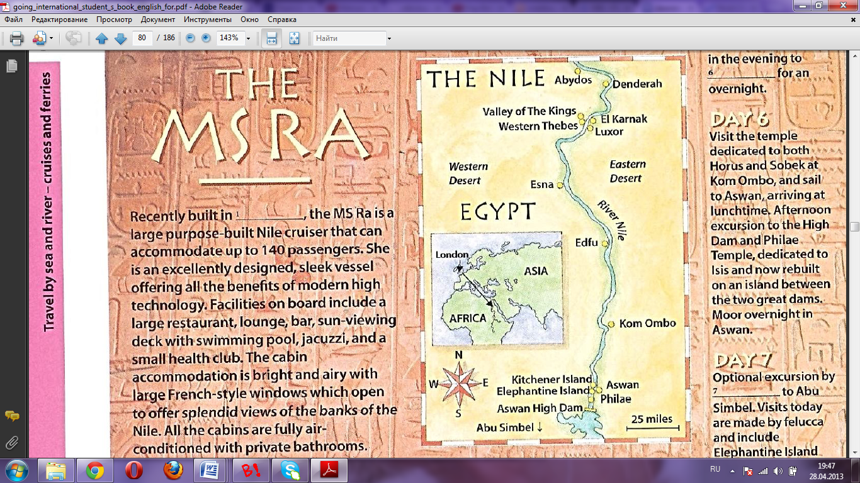
Summary:
On November 2nd I had the good fortune to go on a familiarization trip to Egypt and the River Nile for eight days in order to promote Nile cruises to Belarusian market. I visited the main destinations along the Nile on board of the MS Ra cruiser. I’m completely satisfied with living facilities and attractions but I’d like to improve food service and entertainment program.
Introduction:
As our BONANZATOUR company has decided to bring a new product such as a trip to Egypt and the Nile cruise to market, on November 2nd I started to explore this new destination in order to work out an elaborate trip for Belarusian people and meet their demands of our customers.
Visitor impressions:
Destination appeals to Belarusian people for reasons:
- It’s a unique destination with inimitable and specific traditions. This land that gave birth to the first great civilization. The scope of Egypt is magnificent and tourists from Belarus will become familiar with the pyramids, the minarets, the Nile and other attractions.
- Our citizens can try the ultimate Egyptian adventure and get intimate knowledge about the country.
- By international standards Egypt is still fairly cheap, admission fees, guided tours and private transportation stay within mid-prices.
- Belarusians can save time as they can get an entry visa straight at the airport in Egypt.
- People of Belarus really admire Egyptian weather which is quite predictable: hot and dry with the exception of the winter months of December, January and February. Average temperatures range from 20°C on the Mediterranean coast to 26°C in Aswan. Maximum temperatures for the same places can get up to 31°C and 50°C ,respectively. Egypt can offer all year round vacation which our people really appreciate.
Infrastructure:
Egypt's infrastructure is relatively underdeveloped. Despite the modernization of the road system in the 1980s, most roads remain in poor condition or under construction. With growing numbers of licensed automobiles in the 1990s, the road system, especially in urban areas, has become highly congested, and is a major safety concern. Egypt reports the highest incidence of traffic fatalities in the world. Egypt's aging state-owned railway system is old by regional standards and in need of upgrade. Egypt has a total of 90 airports. Egypt Air, the country's official airline, carries some 4.6 million passengers, roughly 25 percent of international air traffic, but has a poor service record and is generally unreliable. Egypt has 3 major ports, at Alexandria, Port Said, and Suez, and 3,500 kilometers of waterways, divided between the Nile and the canals. Telecommunication services in Egypt are thoroughly modern.
Attractions:
Upon arrival, the choreographed chaos here hits you like a ton of bricks. It doesn’t take long, however, to acclimatise to Cairo’s wall of noise, snarl of traffic, cry of hawkers and blanket of smog, and get drawn into the hypnotising charm of this pulsating metropolis. Known to its nearly 20 million residents as Um ad-Dunya (Mother of the World), modern Cairo is a hotchpotch of recent growth barely superimposed on a dense bed of history. Wander down to Islamic Cairo and you’ll be sucked in through the looking glass to a bygone medieval era. Head out west to Giza’s famed pyramids and the time warp sets you back a full 4000 years. Meanwhile, the city’s main museum bursts at the seams with the priceless wealth of ancient Egypt’s antiquities.
Built around the 4000-year-old site of Thebes, the ancient capital of the New Kingdom, contemporary Luxor is an eccentric combination of provincial town and staggering ancient splendour. The concentration of monuments is extraordinary: they tower incongruously above the buzz of everyday life and make this a most compelling destination.
Egypt’s southernmost city sits on the banks of a particularly beautiful stretch of the Nile, decorated with palm-fringed islands and flotillas of white-sailed feluccas. Associated with the Nubian people, a distinct ethnic group with their own language and customs, the town is more African in character than the cities of the north.
Where northern Upper Egypt is dominated by fast-growing cities and political problems, the country south of Luxor is both harder and calmer. The Nile is increasingly hemmed in by the desert, its banks lined with well-preserved Graeco-Roman temples at Esna, Edfu and Kom Ombo, its lush fields punctuated by palm-backed villages – it’s the perfect place to glide through on a Nile sailing boat. Al-Kab provides the perfect contrast to the grandeur of the temples, for this once-great city has almost completely disappeared. Beyond Edfu the ribbon of cultivation on the Nile’s east bank gives way to the Eastern (Arabian) Desert, while at Gebel Silsila, 145km south of Luxor, the river passes through a gorge, once thought to mark a cataract.
Aswan may be the regional capital and administrative centre, but this ancient ivory-trading post has a laid-back atmosphere that sets it apart from other tourist centres in Egypt. With the Nubia Museum, ancient remains, a vibrant souq, beautiful gardens and a unique Nubian-influenced local culture, it is a fascinating and relaxing place to spend time.
South of Aswan, the land is dominated by the High Dam and its offspring, Lake Nasser, the world’s largest artificial lake. Remarkable monuments that would have been lost to the lake’s waters now stand grouped on its shores and can be visited by boat. Most southerly and spectacular of all is the Great Temple of Ramses II at Abu Simbel, one of ancient Egypt’s most awesome structures and a highlight of any visit to Egypt.
Measuring 6680km in length, the Nile is the world’s longest river. It brought the nation of Egypt into being and its banks are clustered with the temples and tombs of the country’s illustrious past. Luxor and Aswan are the (well-deserved) jewels in the crown and few can resist time spent on the water itself. Nowadays many excursions offer the Nile as the main place of interest but I can not say that all of them are satisfactory because of pollution of the river and its overcrowding by tourists.
More than a temple, Karnak is an extraordinary complex of sanctuaries, kiosks, pylons and obelisks dedicated to the Theban gods and the greater glory of pharaohs. Everything is on a gigantic scale: the site covers over 2 sq km, large enough to contain about 10 cathedrals, while its main structure, the Temple of Amun, is the largest religious building ever built. This was where the god lived on earth, surrounded by the houses of his wife Mut, and their son Khonsu, two other huge temple complexes on this site.
Once called the Great Necropolis of Millions of Years of Pharaoh, or the Place of Truth, the Valley of the Kings has 63 magnificent royal tombs from the New Kingdom period, all very different from each other
The eyes first focus on the dramatic rugged limestone cliffs that rise nearly 300m above the desert plain, a monument made by nature, only to realize that at the foot of all this immense beauty lies a man-made monument even more extraordinary, the dazzling Temple of Hatshepsut. The almost modern-looking temple blends in beautifully with the cliffs from which it is partly cut, a marriage made in heaven.
The first structure you'll see at Abydos is the striking Cenotaph or Great Temple of Seti I, which, after a certain amount of restoration work, is one of the most complete temples in Egypt. This great limestone structure, unusually L-shaped rather than rectangular, was dedicated to the six major gods - Osiris, Isis and Horus, Amun-Ra, Ra-Horakhty and Ptah - and also to Seti I himself.
Elephantine Island is the site of ancient Abu (meaning both elephant and ivory in ancient Egyptian), both names a reminder of the island's once important ivory trade. At the beginning of the 1st dynasty (about 3000 BC) a fortress was built on the island to establish Egypt's southern frontier. Abu soon became an important customs point and trading centre.
Services:
There is an easily accessible and comfortable way to take a Nile cruise trip in Egypt, combining a Nile cruise with visits to some of the most impressive Egyptian historic sights.
Recently built in Britain, the MS Ra is a large purpose-built Nile cruiser that can accommodate up to 140 passengers. She is an excellently design, sleek vessel offering all the benefits of modern high technology. Facilities on board include a large restaurant, lounge, bar, sun-viewing deck with swimming pool, jacuzzi, and a small health club. The cabin accommodation is bright and airy with large French-style windows which open to offer splendid view of the banks of the Nile. All the cabins are fully air-conditioned with private bathrooms.
Conclusion:
I have spent eight days going on a familiarization trip to Egypt and the River Nile in order to work out and then to promote Nile cruises to Belarusian people. I visited the cities staying on the bank of Nile and enjoyed the main attractions such as the Great Temple of Karnak, the Great Temple of Seti I, the dazzling Temple of Hatshepsut, the Valley of the Kings, Elephantine Island and others. Our cruiser was very comfortable and designed according to modern technologies. All necessary facilities and services were provided. The way on board between stops was a bit boring. I would like to get more entertainments. I’m not satisfied with the state of some places of interest. They could be almost destroyed with few things to show. The Nile is highly polluted and it’s difficult to enjoy the trip. When you disembark in order to go on excursion you are to stay in a long queue for getting to this object. Another ways of transportation are not well developed and demand modernization.
Recommendations:
- Infrastructure should be improved. Condition of roads should be made better especially in urban areas. Railway system should be upgraded by delivering of new trains. Air services should become more reliable by implementing new safety measures and standards of quality.
- Problem of the Nile pollution should be solved. Monitoring the canals should be included in the monitoring programs. Information about water quality along the length of drains in Upper Egypt should be presented to the authorities. Data should be available about parameters such as pesticides, heavy metals and hydrocarbons and taken into consideration. There is a lack of intra- and inter-ministerial cooperation and data sharing. Many available reports related to water quality issues should rely only on new water quality data.
- Organization of leisure time on board of cruiser should be improved. For this reason some entertainment actions should be taken. Cruise company can hire entertainment manager or social director for amusement of the guests.
- The cruise company should more control its embarkation and disembarkation timetable. For this reason some modern technologies and computer reservation system will be handy.
- The cruise company should pay more attention to food services on board. Food variety should be diversified. Food establishments for different budget groups of people should be provided.

